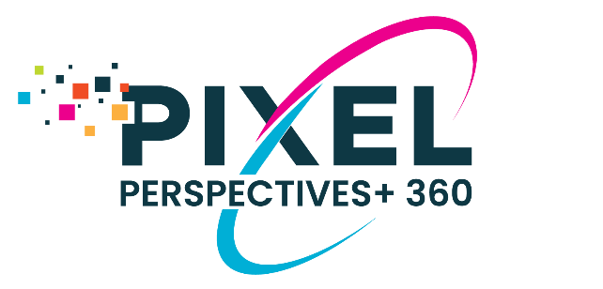

Invitation to Your Raters to Complete Your

Pixel Perspectives+ 360 Insights Tool

Prior to completing your online registration to participate in the Pixel Perspectives+ 360 Insights Tool, please send invitations directly to your raters to inform them of your participation. Once you enter your raters into the online system, they will begin receiving emails directly from Pixel Leadership Group (i.e., Pixel Assessments) requesting them to provide feedback, as well as reminders if they have not yet completed the survey. Sending a message directly from you increases participation of your respondents as it assures them that you are aware and supportive of the process, it demonstrates you are personally invested in the feedback, and it alleviates their concerns about the confidentiality of their responses.
(Please edit the message below to meet your needs.)
Dear Colleague,

As a part of my professional growth and development, I am participating in the Pixel Perspectives+ 360 Insights Tool, which is a multi-rater feedback collection instrument. It will allow me to receive input about my current leadership practices from my supervisor, staff, and other stakeholders (such as peers and business partners).

Pixel Leadership Group, administers the survey, collects and houses the data, and generates the confidential report that only my coach and I will see. The feedback is designed to be developmental to help me to grow as a leader. It will be collected via an online survey and will be completely confidential for individuals in my Staff and Stakeholder groups (that is, I will not know who specifically has provided me the feedback). I encourage you to be candid and complete in your responses as this will help me continue my professional development and increase my effectiveness as a leader.

Soon you will receive an email from Pixel Assessments (assessments@pixelleadershipgroup.com), which will contain all the details about the survey as well as access the survey. The survey should take 5 - 10 minutes to complete.

Thank you in advance for supporting my professional development.

