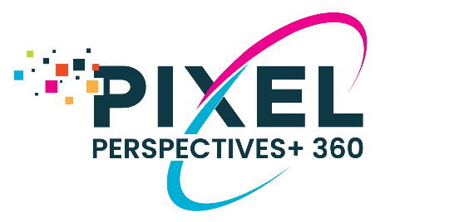

PIXEL PERSPECTIVES+ 360 INSTRUCTIONS
This email template is designed to provide your client with instructions to register and initiate their Pixel Perspectives+ 360 Assessment. Participants should complete their registration by 11:59pm on EST on the Tuesday prior to the Wednesday the tool will launch. Please edit the message below to meet your needs.

Message to Coaching Client
SUBJECT: ACTION REQUIRED: Instructions to Initiate Your Feedback Assessment

EMAIL BODY:
Dear _____,
As a part of your coaching program, I would like you to participate in a multi-rater feedback assessment. This process will provide you valuable insights into your strengths and opportunities to improve as a leader. Your assessment will launch on DATE and close on DATE. You must complete the online registration form by 11:59 PM EST on DATE in order to launch your assessment on time.

We will be using is the Pixel Perspectives+ 360 Insights Tool to collect input from your colleagues. The Pixel Perspectives+ 360 Insights Tool is an online feedback collection instrument that allows you to receive feedback from colleagues about your current leadership practices. You can learn more about the tool and access supplementary resources here. Below I provide an overview of the process and your next steps.

ACTIONS:
- Identify your raters (use this Guide to Selecting Your Raters to help you)
- Send an email to all your raters to inform them about the process. Here is an email template you can use.
- Follow this link to complete the online Pixel Perspectives+ Registration Portal by DATE at 11:59 PM EST

WHAT TO EXPECT:
You and your raters will receive email invitations with a link to the online assessment from Pixel Assessments (assessments@pixelleadershipgroup.com). Your assessment will remain active for 2 weeks. During that time, reminders will be sent by Pixel Assessments, but we also encourage you to send one message to all your raters around the mid-point to remind them, as well. You can use the reminder email template found here for that message.

Your feedback report will be confidential; only you and I will receive a copy of the report. You and I will meet soon after to discuss your results and to create a development plan.

Please let me know if you have any questions.

Warm regards,

Web links used in this email:
Pixel Perspectives+ Registration Portal: https://www.research.net/r/Pixel-PerspectivesRegistration
Pixel Perspectives+ FAQs Website: https://www.pixel-perspectives.com/
Rater Selection Guide: https://www.pixel-perspectives.com/guide-for-selecting-your-raters.html
Email Template for Participant to Inform Raters: https://www.pixel-perspectives.com/email-templates.html

