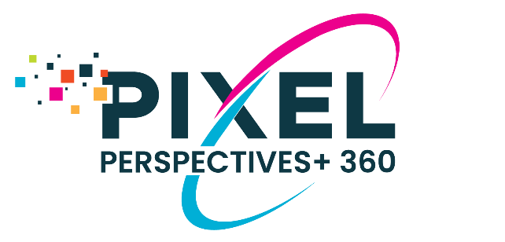

Reminder to Your Raters to Complete Your

Pixel Perspectives+ 360 Change Tool

While reminders are sent through the online system, raters are much more likely to act when receiving reminders directly from the participant. Sending a message directly from you increases participation of your respondents as it assures them that you are aware and supportive of the process, it demonstrates you are personally invested in the feedback, and it alleviates their concerns about the confidentiality of their responses.

(Please edit the message below to meet your needs.)
Dear Colleague,

As you are aware, I am seeking your input through the Pixel Perspectives+ 360 Change Tool, an online feedback assessment, to support my growth and development as a leader. Thank you to all of you who have already devoted the time to invest in my development by completing the assessment.

If you have not yet completed the tool, please be sure that you do so by YOUR CLOSE DATE.

You should have received an invitation email from Pixel Assessments (assessments@pixelleadershipgroup.com) that contained all the details about the survey as well as a link to access the survey. Please let me know if you did not receive that email from Pixel Assessments. The survey should take 5 - 10 minutes to complete.

I truly appreciate your participation in this process and look forward to receiving your authentic feedback.

