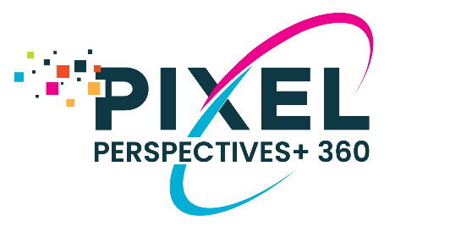

PIXEL PERSPECTIVES+ 360 REPORT DISTRIBUTION
This email template is designed to be used when sending your client their Pixel Perspectives+ 360 Insight Development Report and the Insights Accelerator Workbook. Please edit the message below to meet your needs.

ATTACH TO THIS EMAIL
- Pixel Perspectives+ 360 Insight Development Report
- Pixel Perspectives+ Insights Accelerator Workbook

Message to Coaching Client
SUBJECT: ACTION REQUIRED: Instructions to Initiate Your Feedback Assessment

EMAIL BODY:
Dear _____,

I am pleased to share with you your Pixel Perspectives+ 360 Insight Development Report (attached). Please review this before our next meeting and come prepared ready to discuss.

BEFORE REVIEWING YOUR REPORT: First review the attached Insights Accelerator Workbook. This document is designed to be used side-by-side from your very first reading of the report. It will walk you through each section and includes reflection questions to help you interpret your report. Take note of anything that seems to fit you well and anything that is a surprise.

Please let me know if you have any questions. I look forward to discussing these with you soon.

Best regards,
YOUR NAME

